The “Webspace” is the hosted filesystem.

Access the “WebSpaceExplorer” from the Control Panel ->Hosting-> . -> Launch. The WebFiles dialog appears

Inside of the Webspace, create a folder for each website.

So for the test website, the folder will be TestATAPConsusltingCom; for Production the folder will be wwwATAPConsultingCom

Domains and subdomains are created and administered by 1And1.

Domains and subdomains are assigned to webspace folders.

Domain ATAPConsulting.com and subdomain [www.atapconsulting.com](http://www.atapconsulting.com) are both assigned to webspace folder wwwATAPConsultingCom.

Domain test.atapconsulting.com are assignged to webspace folder testATAPConsuslting.com

1AND1 allows for “unlimited” FTP userids.

FTP UserIDS , once login occurs, point the root of their FTP directory to a WebSpace folder.

FTP UerID ftp49008251-1 is for access to the test webspace folder, /TestATAPConsultingCom.

After ensuring the webspace folder, subdomain, and FTP UserId/pwd are created and setup, the pages/code for the site can be deployed to 1and1

Visual Studio 2017 publish profile creation dialog box:

Server is home242383179.1and1-data.host

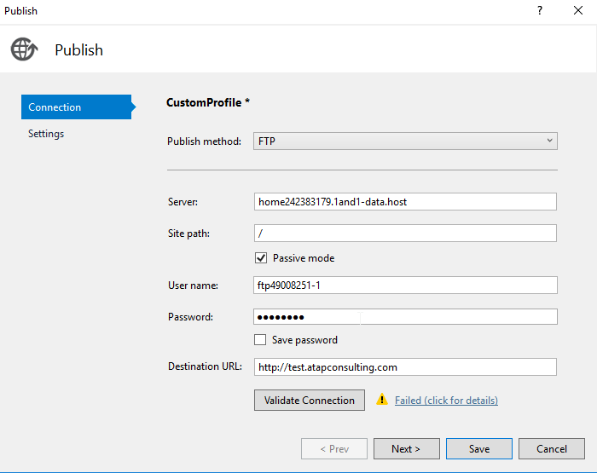

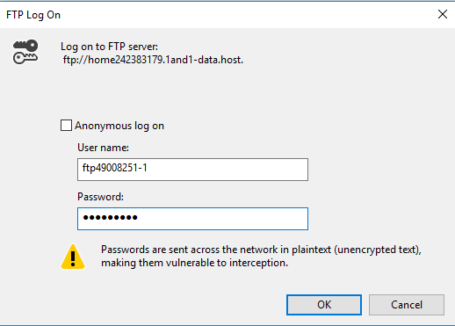

After entering correct Server, User Name, and {Password, a green checkmark appears in dialog

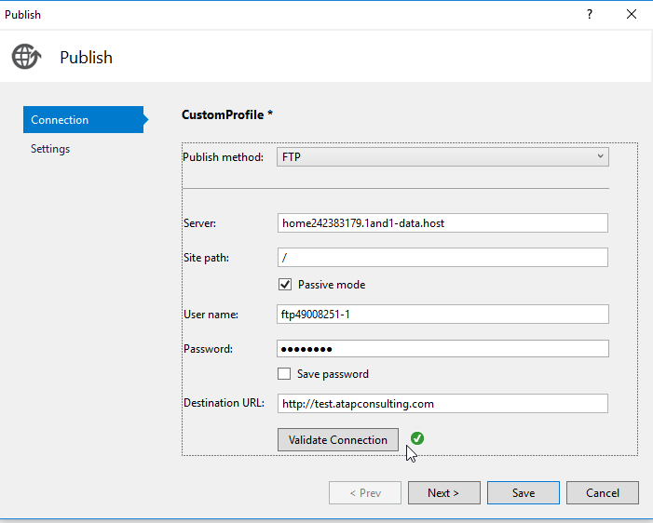

Next step will “save” the profile.

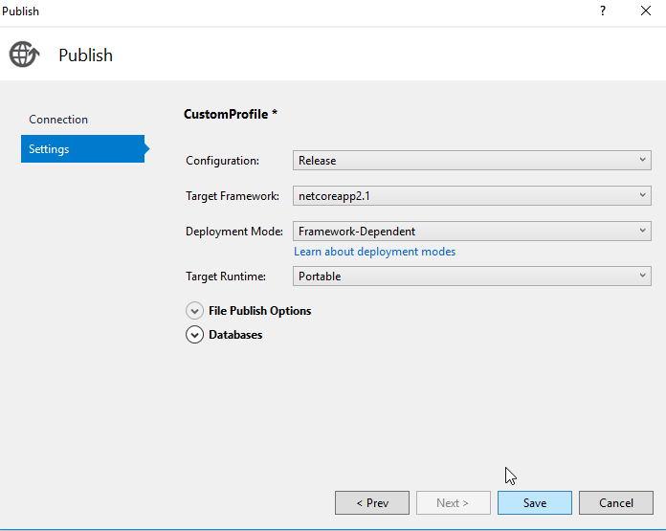

Now the Visual Studio Publish tab has a lot more information

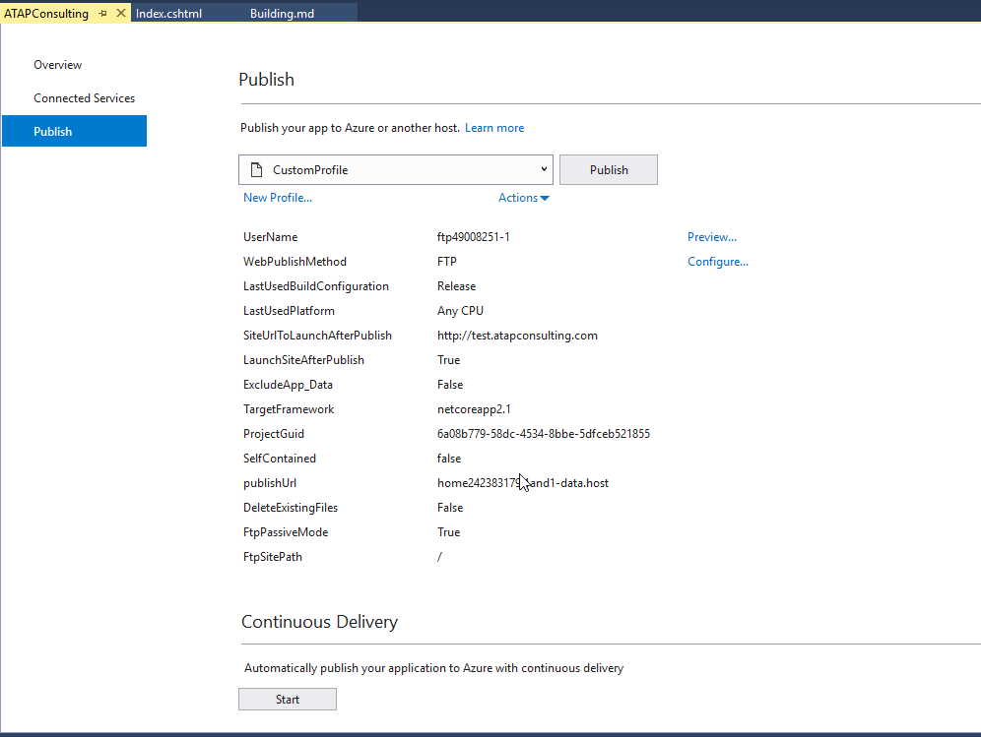

Now rename this profile

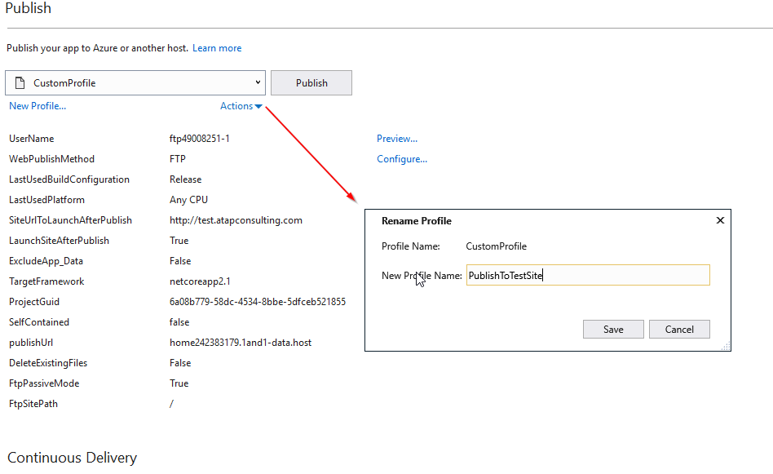

And the publish tab is now shorter

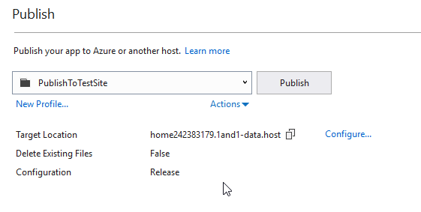

Pressing “publish” brings up the FTP login dialog (remember, do NOT save the password in the profile!)

Visual Studio Output windows shows a lot of lines as it prepares for, and the sends, the website up to 1And1

After publish, it opens a browser to test.atapconsulting.com, and the website appears.

